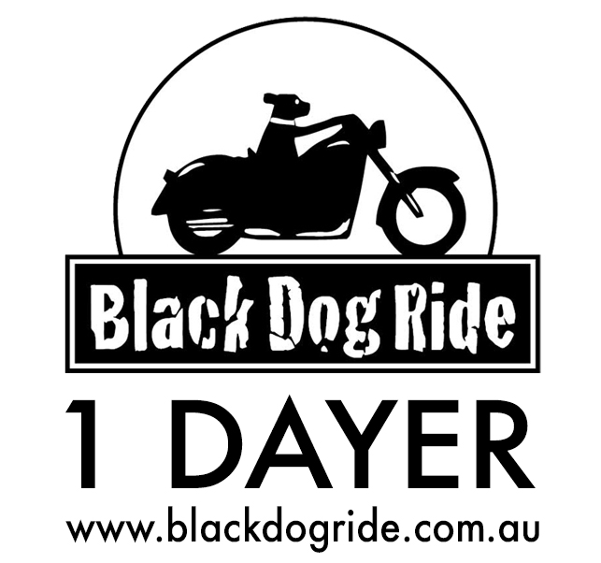
DATE: 18th MARCH 2018

RIDE REGION:

REGISTRATION PRICE:
MC RIDER: $30 and MC PILLION $15

Participant information to support Black Dog Ride’s suicide prevention project planning
These questions are entirely voluntary and confidential. We appreciate your input to help us plan appropriate activities which promote awareness of depression and suicide prevention.
Do you identify as (tick as many as apply to you): ◻ Aboriginal or Torres Strait Islander ◻ LGBTQI* ◻ ex/serving Defence/Emergency Service ◻ Paramedic/Nurse/Dr ◻ trained in Mental Health First Aid
Do you have lived experience with (tick as many as apply to you): ◻ suicide or suicidal ideation
◻ suicide bereavement ◻ caring for someone with a mental illness ◻ living with mental illness
If you answered yes to any of the above, would you be willing to share your story with us? ◻ Yes ◻ No
Would you be interested in learning more about (tick as many as apply): ◻ volunteering with BDR
◻ training in Mental Health First Aid ◻ participating in other local BDR activities ◻ sponsoring BDR
Consent to share information with Indian Motorcycle
I consent to Black Dog Ride Australia Ltd using and disclosing my name and email address, gender and age (if provided) to Indian Motorcycle Company Pty Ltd to receive future promotional materials from Indian Motorcycle Company (please tick) ◻ YES or ◻ NO

Adult Rider or Pillion Information – Strictly 1 Form Per Person
◻ Rider ◻ Pillion | ◻ Male ◻ Female ◻ Other |  | Name:
Email Address:
Mobile Number:
In Case of Emergency – This Information Is Only Required to Support You In Case of Emergencies
Your Date of Birth: / / |  | NOK Name (not your pillion!):
NOK Relationship: |  | NOK Phone:
Bike Brand, Make & Rego (Plate) Number:
Medical Issues:
Black Dog Ride 1 Dayer Disclaimer
I, the aforementioned registered participant in Black Dog Ride’s 1 Dayer acknowledge I have read and
accept the attached Terms and Conditions (Disclaimer) for participation in this 1 Dayer, and acknowledge the risks arising from attending or participating in this 1 Dayer, and being provided with services in the 1 Dayer by Black Dog Ride Australia Ltd organisers, by signing below:
Signature: ________________________________________ Date: ________________________________

